Assignment no.1
Unit 1 : Arrays
Course Name : Data Structures-I
Course Code : CS2301
Div : SEDA-B
Student Name : Yashraj Dinesh Hande
Roll Number : 18
Date of Submission : 23/11/2025
Arrays
🔹 Introduction
An array is a collection of elements of the same data type stored in contiguous memory locations.
It allows storing multiple values under a single variable name and accessing them using an index.
Arrays are one of the most fundamental data structures in programming, providing sequential access and efficient memory usage.

🔹 Types of Arrays
- One-Dimensional Array (1-D):
Stores data elements in a single row or column.
Example: int arr[5] = {10, 20, 30, 40, 50};
- Two-Dimensional Array (2-D):
Stores elements in rows and columns (like a table or matrix).
Example: int mat[3][3];
- Multi-Dimensional Array:
Arrays with more than two dimensions, used in complex applications such as image or tensor representation.

🔹 Memory Representation
- Arrays are stored in contiguous memory blocks.
- The array name represents the base address of the memory block.
- The index helps calculate the address of any element using the formula:
$$\text{Address}(A[i])=\text{Base Address}+i×\text{Size of data type}$$
- In Row-Major Order, elements of each row are stored sequentially (default in C/C++).
- In Column-Major Order, elements of each column are stored sequentially (used in Fortran, MATLAB, etc.).

🔹 Advantages of Arrays
- Easy to access elements using index.
- Efficient memory utilization for fixed-size collections.
- Simple traversal and searching operations.
- Foundation for advanced data structures (stack, queue, matrix).

🔹 Limitations of Arrays
- Fixed size — cannot grow dynamically.
- Insertion and deletion operations are time-consuming.
- Wastage of memory if declared size is not fully used.

🔹 Applications of Arrays
- Storing and processing lists of data (marks, salaries, temperatures).
- Implementing matrices and performing mathematical computations.
- Handling strings using character arrays.
- Representing sparse matrices efficiently.
- Used in sorting, searching, and data analysis algorithms.

Problem 1 : Implement basic string operations such as length calculation, copy, reverse, and concatenation using character single dimensional arrays without using built-in string library functions.
Code :
#include <iostream>
using namespace std;

//find lenght
void len(char str1[])
{
int i=0;
while(str1[i]!=0){
i++;
}
cout<<"length of "<<str1<<" is :"<<i<<endl;

}

//concatenate
void concat(char str1[], char str2[])
{
int i=0;
while(str1[i]!=0){
i++;
}
cout<<"length of str 1 :"<<i<<endl;

int j=0;
while(str2[j]!=0)
{
str1[i]=str2[j];
i++;
j++;
}
str1[i]='\0';
cout<<"Concatenated String :"<<str1;
}

//Reverse the string
void reverse(char str1[])
{
//finds the last index of string
int i=0;
int count=0;
while(str1[i]!=0){
i++;
count++;
}

//traverse from last index i.e count-1
int j=0;
char rev_str[50];
for (int i=count-1; i>=0; i--){
rev_str[j]=str1[i];
j++;
}
rev_str[j]='\0';
cout<<"The reversed string is :"<<rev_str;
}

//copy
void copyStr(char src[], char dest[]) {
int i = 0;
while (src[i] != 0) {
dest[i] = src[i];
i++;
}
dest[i]=0;
cout << "Copied String: " << dest << endl;
}

int main(){
char str1[50], str2[50];
cout<<"Enter first String :";
cin>>str1;

menu:
int choice=0;
cout << "\nMenu:\n";
cout << " 1. Find Length\n 2.Concatenation \n 3.Reverse. \n 4.Copy. \n 5.Exit :\n";
cin >> choice;
switch(choice){
case 1:
len(str1);
break;
case 2:
cout<<"Enter String to concatenate :";
cin>>str2;
concat(str1,str2);
break;
case 3:
reverse(str1);
break;
case 4:
copyStr(str1,str2);
break;
case 5:
exit(0);
default:
cout<<"Please enter valid Choice !!";
}
goto menu;
}

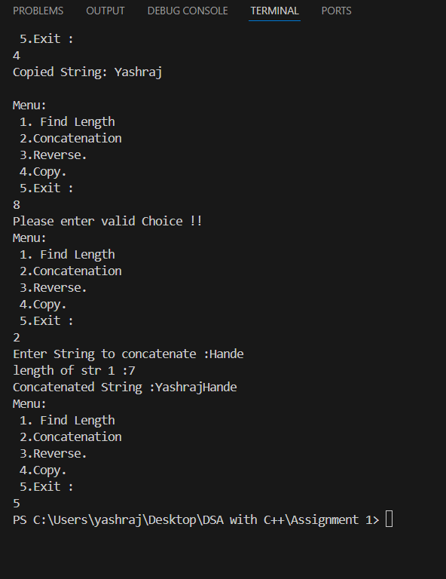
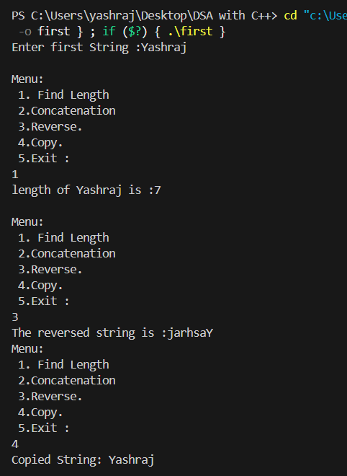

Problem 2 : Write a program to construct and verify a magic square of order 'n' (for both even & odd) such that all rows, columns, and diagonals sum to the same value.

#include <iostream>
#include <iomanip>
using namespace std;

// Function to print the square
void printSquare(int n, int square[50][50]) {
cout << "\nMagic Square of order " << n << ":\n";
for (int i = 0; i < n; i++) {
for (int j = 0; j < n; j++) {
cout << setw(4) << square[i][j] << " ";
}
cout << endl;
}
cout << endl;
}

// Odd order magic square (Siamese method)
void generateOddMagicSquare(int n, int square[50][50]) {
// Initialize with 0
for (int i = 0; i < n; i++)
for (int j = 0; j < n; j++)
square[i][j] = 0;

int i = n / 2;
int j = n - 1;

for (int num = 1; num <= n * n; num++) {
square[i][j] = num;

i--; j++;

if (i == -1 && j == n) { i = 0; j = n - 2; }
if (i < 0) i = n - 1;
if (j == n) j = 0;
if (square[i][j] != 0) { i += 1; j -= 2; }
}
}

// Even order magic square (doubly even method)
void generateEvenMagicSquare(int n, int square[50][50]) {
// Works only for doubly even (n % 4 == 0)
int num = 1;
int num2 = n * n;

for (int i = 0; i < n; i++) {
for (int j = 0; j < n; j++) {
if ((i % 4 == j % 4) || ((i + j) % 4 == 3))
square[i][j] = num2;
else
square[i][j] = num;
num++;
num2--;
}
}
}

int main() {
int n, choice;
int square[50][50];

cout << " MAGIC SQUARE PROGRAM \n";
cout << "-------------------------------\n";

menu:
cout << "Menu:\n";
cout << " 1. Generate Magic Square (Odd n)\n";
cout << " 2. Generate Magic Square (Even n-->doubly even)\n";
cout << " 3. Exit\n";
cout << "Enter your choice: ";
cin >> choice;

switch (choice) {
case 1:
cout << "Enter odd order (n): ";
cin >> n;
if (n % 2 == 0) {
cout << "Please enter an odd value of n.\n";
} else {
generateOddMagicSquare(n, square);
printSquare(n, square);
}
break;

case 2:
cout << "Enter even order (n): ";
cin >> n;
if (n % 4 != 0) {
cout << "Please enter doubly even n (n % 4 == 0).\n";
} else {
generateEvenMagicSquare(n, square);
printSquare(n, square);
}
break;

case 3:
cout << "Exiting program. Thank you!\n";
return 0;

default:
cout << "Invalid choice! Try again.\n";
}
goto menu;
}

Output :
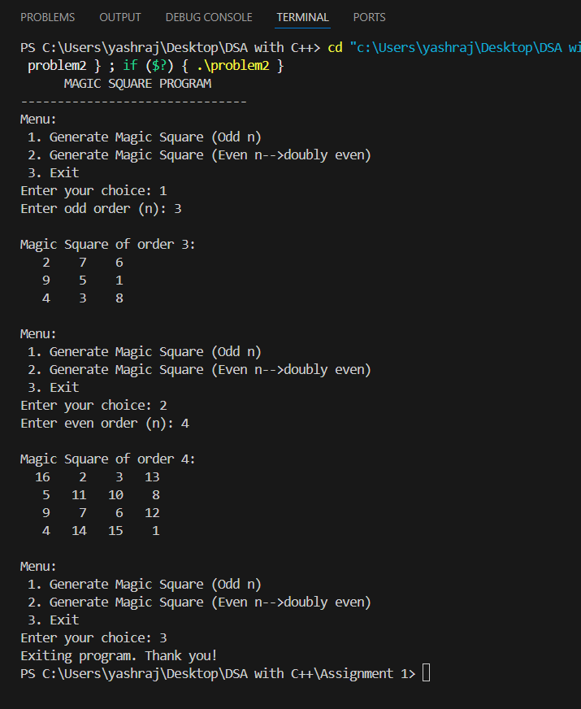

Problem 3 : Implement matrix multiplication and analyse its performance using row-major vs column-major order access patterns to understand how memory layout affects cache performance.

#include <iostream>
#include <vector>
#include <chrono>
using namespace std;
using namespace std::chrono;

class Matrix {
private:
int rows, cols;
vector<vector<int>> mat;

public:
Matrix(int r, int c) : rows(r), cols(c) {
mat.resize(rows, vector<int>(cols, 0));
}

void inputMatrix() {
cout << "Enter elements (" << rows << "x" << cols << "):\n";
for (int i = 0; i < rows; i++)
for (int j = 0; j < cols; j++)
cin >> mat[i][j];
}

void displayMatrix() const {
for (int i = 0; i < rows; i++) {
for (int j = 0; j < cols; j++)
cout << mat[i][j] << "\t";
cout << "\n";
}
}

Matrix multiplyRowMajor(const Matrix &B) {
Matrix result(rows, B.cols);

auto start = high_resolution_clock::now();
for (int i = 0; i < rows; i++)
for (int j = 0; j < B.cols; j++)
for (int k = 0; k < cols; k++)
result.mat[i][j] += mat[i][k] * B.mat[k][j];
auto end = high_resolution_clock::now();

cout << "\nRow-Major Multiplication Time: "
<< duration_cast<milliseconds>(end - start).count()
<< " ms\n";

return result;
}

Matrix multiplyColumnMajor(const Matrix &B) {
Matrix result(rows, B.cols);

auto start = high_resolution_clock::now();
// Notice the different loop order: this simulates column-major access
for (int j = 0; j < B.cols; j++)
for (int k = 0; k < cols; k++)
for (int i = 0; i < rows; i++)
result.mat[i][j] += mat[i][k] * B.mat[k][j];
auto end = high_resolution_clock::now();

cout << "\nColumn-Major Multiplication Time: "
<< duration_cast<milliseconds>(end - start).count()
<< " ms\n";

return result;
}
};

// Menu-driven driver code
int main() {
int r1, c1, r2, c2, choice;
cout << "=== MATRIX MULTIPLICATION & CACHE PERFORMANCE ANALYSIS ===\n";

cout << "Enter rows and columns of Matrix A: ";
cin >> r1 >> c1;
cout << "Enter rows and columns of Matrix B: ";
cin >> r2 >> c2;

if (c1 != r2) {
cout << "Matrix multiplication not possible! (c1 != r2)\n";
return 0;
}
Matrix A(r1, c1), B(r2, c2), C(r1, c2);
cout << "\nEnter elements for Matrix A:\n";
A.inputMatrix();
cout << "\nEnter elements for Matrix B:\n";
B.inputMatrix();
while (true) {
cout << "\n----- MENU -----\n";
cout << "1. Display Matrix A\n";
cout << "2. Display Matrix B\n";
cout << "3. Multiply (Row-Major Order)\n";
cout << "4. Multiply (Column-Major Order)\n";
cout << "5. Compare Both\n";
cout << "6. Exit\n";
cout << "Enter your choice: ";
cin >> choice;
switch (choice) {
case 1:
cout << "\nMatrix A:\n";
A.displayMatrix();
break;
case 2:
cout << "\nMatrix B:\n";
B.displayMatrix();
break;
case 3:
cout << "\nResult (Row-Major Order):\n";
C = A.multiplyRowMajor(B);
C.displayMatrix();
break;
case 4:
cout << "\nResult (Column-Major Order):\n";
C = A.multiplyColumnMajor(B);
C.displayMatrix();
break;
case 5: {
cout << "\n--- Comparing Cache Performance ---\n";
A.multiplyRowMajor(B);
A.multiplyColumnMajor(B);
cout << "Observe which access pattern performs faster.\n";
break;
}
case 6:
cout << "Exiting... Thank you!\n";
return 0;
default:
cout << "Invalid choice! Try again.\n";
}
}
}

Output :
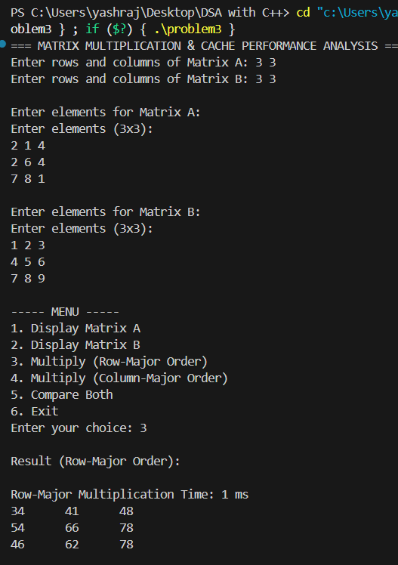
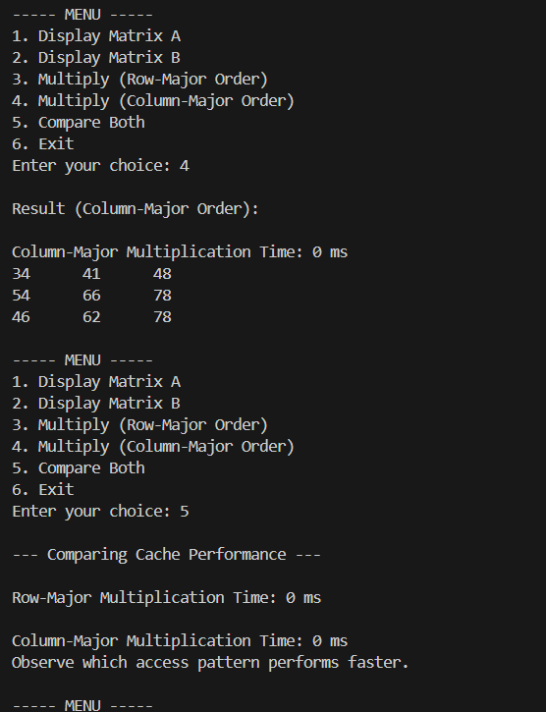

Problem 4 : Develop a program to identify and efficiently store a sparse matrix using compact representation and perform basic operations like display and simple transpose.
#include <iostream>
using namespace std;
int main() {
int rows, cols;
cout << "Enter number of rows: ";
cin >> rows;
cout << "Enter number of cols: ";
cin >> cols;
int normal[50][50];
cout << "\nEnter matrix values:\n";
for (int i = 0; i < rows; i++) {
for (int j = 0; j < cols; j++) {
cout << "Element [" << i << "][" << j << "]: ";
cin >> normal[i][j];
}
}
// Display normal matrix
cout << "\nOriginal Matrix:\n";
for (int i = 0; i < rows; i++) {
for (int j = 0; j < cols; j++) {
cout << normal[i][j] << " ";
}
cout << endl;
}
// Convert to sparse matrix
int sparse[100][3]; // First row is header
int k = 1; // Start filling from index 1

for (int i = 0; i < rows; i++) {
for (int j = 0; j < cols; j++) {
if (normal[i][j] != 0) {
sparse[k][0] = i; // row
sparse[k][1] = j; // col
sparse[k][2] = normal[i][j]; // value
k++;
}
}
}
// Store header row [rows cols nonZeroCount]
sparse[0][0] = rows;
sparse[0][1] = cols;
sparse[0][2] = k - 1;

// Display sparse matrix
cout << "\nSparse Matrix (Row Col Value):\n";
for (int i = 0; i < k; i++) {
cout << sparse[i][0] << " "
<< sparse[i][1] << " "
<< sparse[i][2] << endl;
}
// Simple transpose
cout << "\nSimple Transpose (Row Col Value):\n";
cout << sparse[0][1] << " "
<< sparse[0][0] << " "
<< sparse[0][2] << endl;

for (int i = 1; i < k; i++) {
cout << sparse[i][1] << " " // swap row & col
<< sparse[i][0] << " "
<< sparse[i][2] << endl;
}
return 0;
}
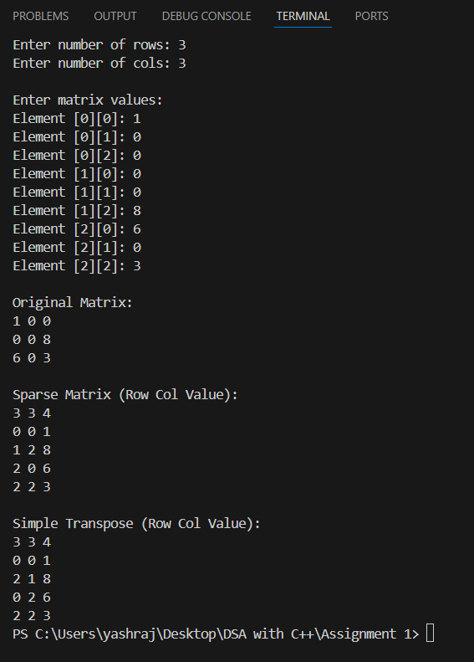

Problem 5 : Develop a program to compute the fast transpose of a sparse matrix using its compact (triplet) representation efficiently.
Code :
#include <iostream>
using namespace std;

int main() {
int rows, cols, terms;
cout << "Enter number of rows, cols, and non-zero terms: ";
cin >> rows >> cols >> terms;

int sparse[terms][3];
cout << "Enter Sparse Matrix (Row Col Value):\n";
for (int i = 0; i < terms; i++) {
cin >> sparse[i][0] >> sparse[i][1] >> sparse[i][2];
}

cout << "\nOriginal Sparse Matrix (Row Col Value):\n";
for (int i = 0; i < terms; i++) {
cout << sparse[i][0] << " " << sparse[i][1] << " " << sparse[i][2] << endl;
}

// Fast Transpose
int fast[terms][3];
int count[cols] = {0}; // count of elements in each column
int index[cols]; // starting index for each column

// Step 1: Count elements in each column of original
for (int i = 0; i < terms; i++) {
count[sparse[i][1]]++;
}

// Step 2: Starting index for each column in transposed
index[0] = 0;
for (int i = 1; i < cols; i++) {
index[i] = index[i - 1] + count[i - 1];
}

// Step 3: Place elements directly in correct position
for (int i = 0; i < terms; i++) {
int col = sparse[i][1];
int pos = index[col];
fast[pos][0] = sparse[i][1]; // new row = old col
fast[pos][1] = sparse[i][0]; // new col = old row
fast[pos][2] = sparse[i][2]; // value stays
index[col]++;
}

cout << "\nFast Transposed Sparse Matrix (Row Col Value):\n";
for (int i = 0; i < terms; i++) {
cout << fast[i][0] << " " << fast[i][1] << " " << fast[i][2] << endl;
}

return 0;
}

